**National University of Computer and Emerging Sciences, Karachi  
FAST School of Computing**

**AL2002 / AI2002 -Artificial Intelligence, Spring 2024**

**Project Title:**

**AI Gym Trainer and Fit Sync App**

**Course Instructors**

Ms. Mafaza Mohi

Ms. Fizza Aqeel

**Group Members**

Kantesh Kumar (21K-3426)

Talha Shahid (21K-3355)

Ahsan Ashraf (21K-3186)

**Introduction:**

In today's fast-paced world, maintaining a healthy lifestyle has become increasingly important. However, many individuals struggle to find the time or motivation to engage in regular exercise. To address this issue, we have developed an innovative solution: the AI Gym Trainer, coupled with the Fit Sync Android app. This comprehensive system aims to revolutionize the way people approach fitness by providing personalized workout guidance and seamless integration with their mobile devices.

**AI Gym Trainer:**

The AI Gym Trainer serves as the backbone of our project. It utilizes computer vision techniques to analyze users' movements during various exercises, providing real-time feedback and tracking their progress. The trainer offers a range of exercises, including single dumbbell curls, reverse flies, barbell curls, push-ups, and deadlifts, catering to users with different fitness goals and preferences.

Key features of the AI Gym Trainer include:

* **Exercise Selection:** Users can choose from a diverse set of exercises based on their preferences and fitness level.
* **Real-time Feedback:** The trainer provides instant feedback on users' form and technique, helping them perform exercises correctly and minimize the risk of injury.
* **Rep Counting:** Using advanced pose detection algorithms, the trainer accurately counts repetitions for each exercise, allowing users to track their progress over time.
* **Customization:** The trainer adapts to users' individual capabilities and adjusts the difficulty level of exercises accordingly, ensuring a personalized workout experience.

**Fit Sync Android App:**

The Fit Sync Android app boasts an intuitive and user-friendly interface, designed to streamline the workout tracking process and enhance the user experience. With a sleek design and seamless navigation, the app provides users with easy access to a range of exercises, including bicep curls, deadlifts, push-ups, barbell curls, and reverse flies.

Key features of the Fit Sync Android app include:

* **Exercise Selection:** Users can choose from a variety of exercises tailored to their fitness goals and preferences. Whether they're targeting specific muscle groups or looking for full-body workouts, the app offers a diverse selection of exercises to suit every need.
* **Real-time Movement Tracking:** The app utilizes advanced motion tracking technology to monitor users' movements during each exercise accurately. By analyzing posture and form in real-time, users can ensure they're performing each movement correctly and safely.
* **Rep Counting:** Fit Sync automatically counts repetitions for each exercise, eliminating the need for manual tracking. Users can focus on their workout without worrying about keeping count, allowing for a more immersive and productive training session.
* **Calorie Recommendation:** Leveraging the power of machine learning, Fit Sync provides users with personalized calorie recommendations based on their individual inputs. Using linear regression models, the app calculates users' daily caloric needs, helping them maintain a balanced diet and achieve their fitness goals more effectively.
* **Frontend with Flutter, Backend with Flask:** The Fit Sync app leverages the versatility of Flutter for its frontend development, ensuring a smooth and responsive user interface across various Android devices. Meanwhile, the backend logic is powered by Flask, a lightweight and flexible web framework, enabling seamless communication between the app and server.

**Integration:**

Fit Sync seamlessly integrates with the AI Gym Trainer, allowing users to synchronize their workout data across both platforms effortlessly. Whether they're tracking their progress on the app or using the AI Gym Trainer for real-time feedback during workouts, users can access their data anytime, anywhere, ensuring a consistent and cohesive fitness experience However due to low processing power and some other reasons, it offers delay in feedback which will be catered in future.

**Tools and technologies:**

* **Languages**: Python 3, Dart
* **Libraries / Frameworks**: Open-CV, Mediapipe, gtts, Flask, Flutter, playsound and tkinter

**Project Screenshots:**

1. **Model:**

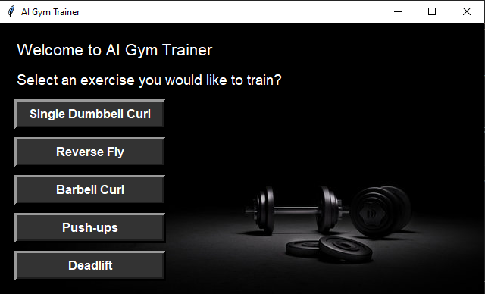

1. **Bicep Curl:**

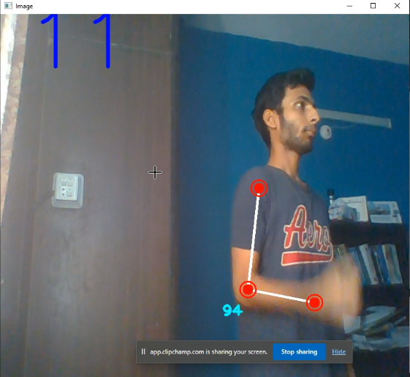

1. **Reverse Fly:**

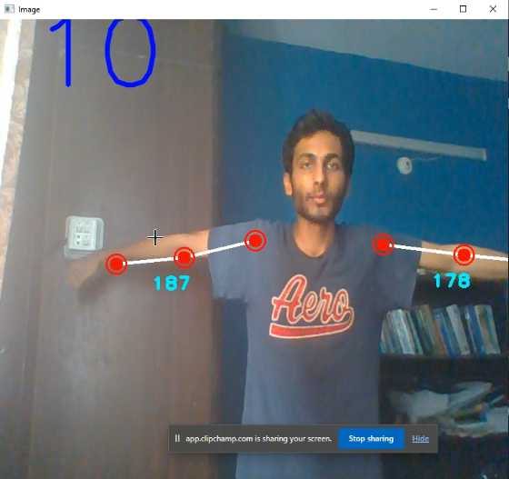

1. **Barbell Curl:**

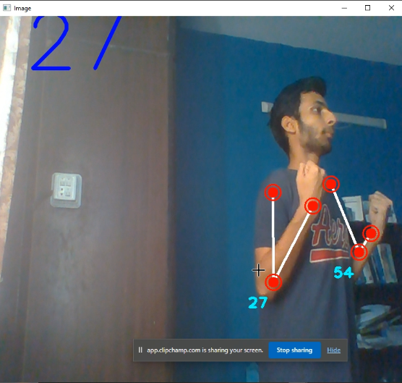

1. **Pushup:**

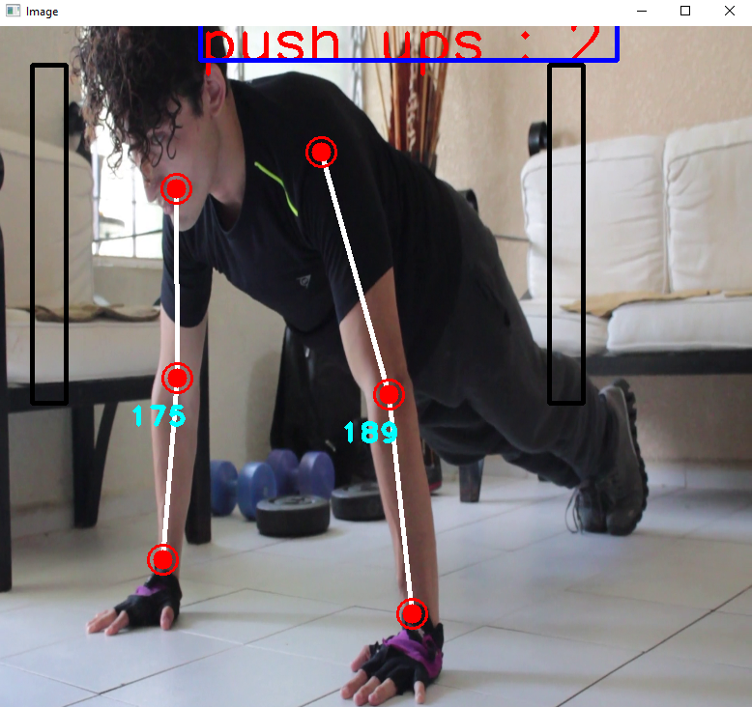

1. **Deadlift:**

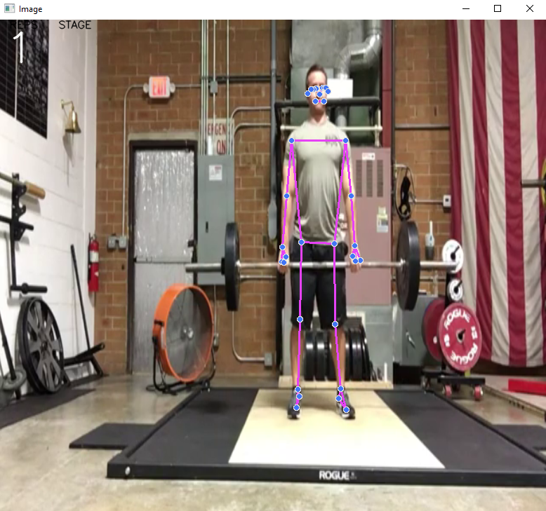

1. **Fit Sync App:**

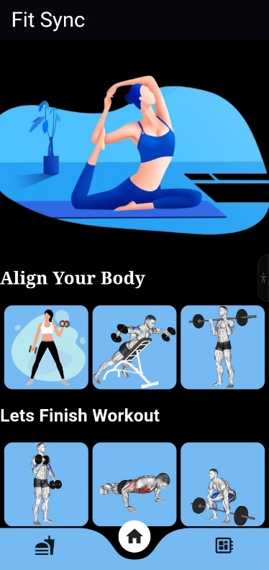

**Future Work:**

* **Reduced Latency:** Optimize code efficiency and data processing algorithms to minimize delays and ensure a smoother user experience.
* **Enhanced Synchronization**: Improve data synchronization protocols to ensure seamless transfer of workout data between the app and backend server.
* **Refined Machine Learning:** Continuously refine machine learning algorithms for more accurate calorie recommendations and personalized fitness insights.
* **Diet Prediction System:** Aim to integrate a diet prediction system with the app and models to give user a whole package of their fitness needs.
* **User Feedback Mechanisms:** Implement feedback mechanisms to gather user insights and prioritize feature enhancements based on user needs.

**Conclusion:**

The Fit Sync Android app represents a significant step forward in the realm of fitness technology, offering users a convenient and intuitive solution for tracking their workouts, monitoring their progress, and achieving their fitness goals. With its user-friendly interface, advanced features, and seamless integration with the AI Gym Trainer, Fit Sync empowers users to take control of their health and fitness journey with confidence.

As we continue to innovate and expand our platform, we remain committed to providing users with the tools and support they need to lead healthier, happier lives. Thank you for your interest in Fit Sync, and we look forward to helping you achieve your fitness aspirations.

**References:**

* OpenCV: [OpenCV: OpenCV Tutorials](https://docs.opencv.org/4.x/d9/df8/tutorial_root.html)
* Mediapipe: [MediaPipe Studio (google.com)](https://mediapipe-studio.webapps.google.com/home)
* AI Gym Trainer: [IRJET-V10I1131.pdf](https://www.irjet.net/archives/V10/i1/IRJET-V10I1131.pdf)